1. In a Point Of Sale (POS) system the following classes constitute the domain

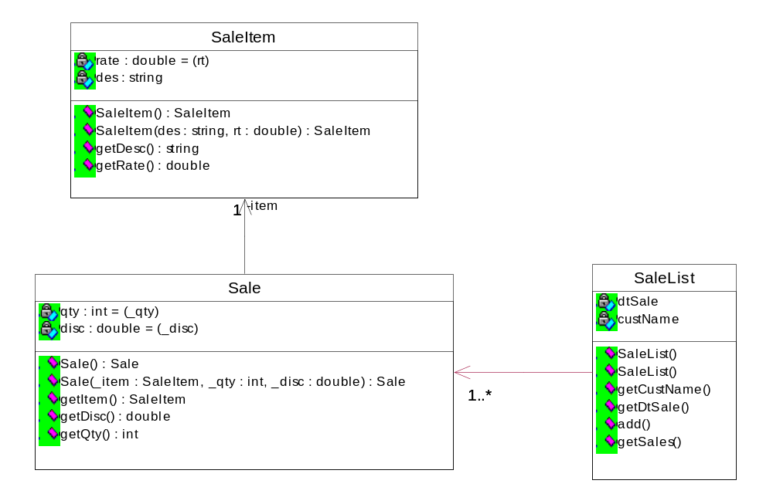
A SaleList has many Sale objects for a given customer. A Sale object is created whenever a Sale is made and contains information about the SaleItem being sold. The SaleItem is the item that is sold and has rate and description. The SaleList needs to use a linked list for storing many Sale objects.

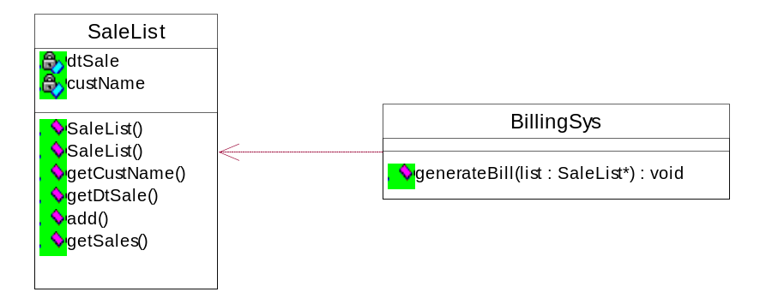

The BillingSys has a method called generateBill to which the object of SaleList is provided. This method finds the grand total for the sale list by considering the qty and discount (from Sale) and the rate (from SaleList).

Every time a sale is made some taxes need to be levied. For this purpose, there is a StdTaxCalc (a tax calculator) which helps in finding the IST (inter-state tax) and FedTax (Federal Tax). To create an object of the StdTaxCalc use the TaxCalcFactory which is implemented as a Singleton. The BillingSys in its constructor, invokes the TaxCalcFactory and gets the StdTaxCalc object. This object is stored in the BillingSys class as a data member.

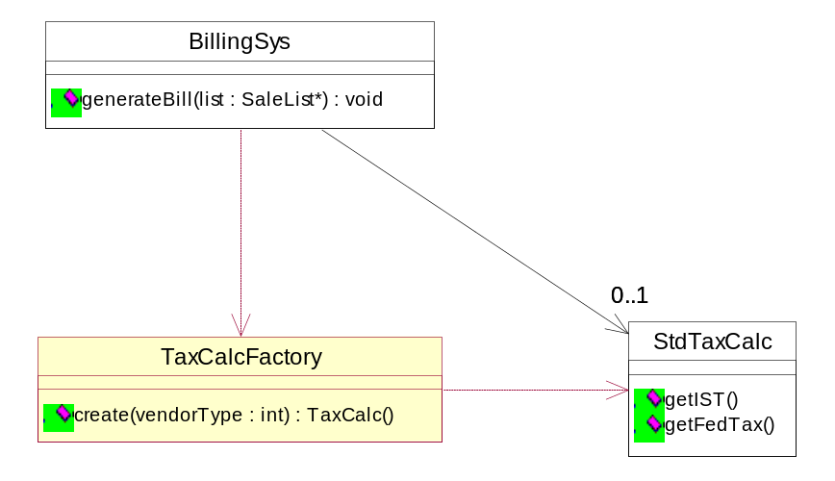

The values for the two types of taxes are currently 10% for IST and 0.15% for FedTax. These values can be revised frequently.

The test code is given below (C++)

SaleItem item1("Monitor",7000); // desc and rate
SaleItem item2("Hard disk",5500);

Sale *sale1 = new Sale(item1,2,5); // item, qty and discount
Sale *sale2 = new Sale(item2,5,10);

SaleList *list = new SaleList("16-03-2006","Jennifer");
list->add(sale1);
list->add(sale2);

BillingSys *sys = new BillingSys();
sys->generateBill(list);

